**Test Automation - Assessment**

**Application to be tested - URL:**

<https://www.amazon.in>

**Tasks:**

* Go to https://www.amazon.in

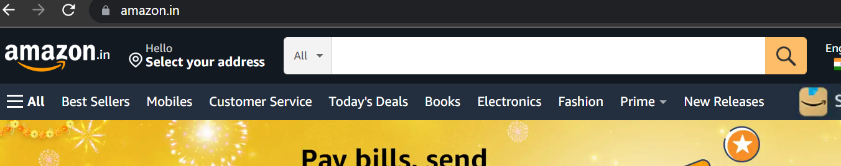

* Click the “Today’s Deals” tab

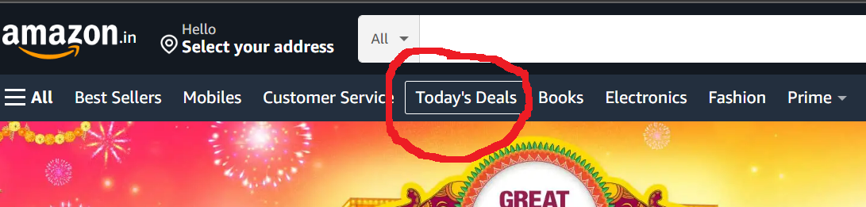

* Click the “Clearance” link

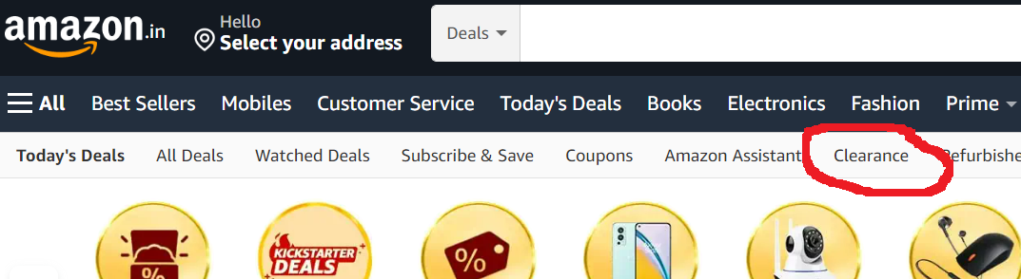

* Click “Watches”

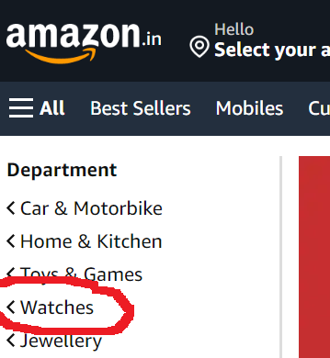

* Click “Get it Today” checkbox

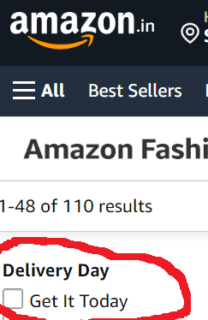

* Validate if “RESULTS” message is displayed
* Validate if the first item has item name containing “Watch”

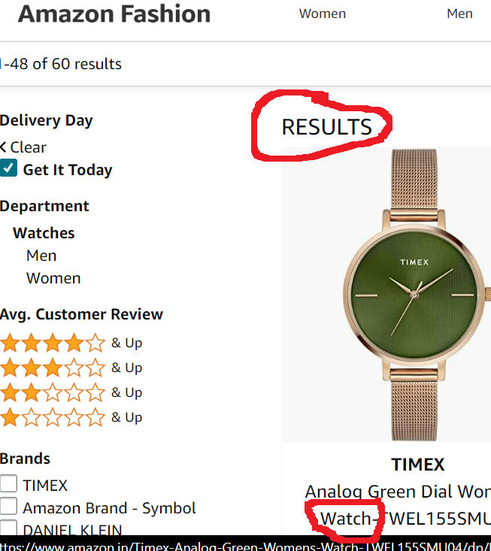

**Refer screenshot for each step**